Preliminary Work Report

# Images found

For the training image, we found a database that contains pictures with face in the center and with different emotions. In the database, we have pictures of 100 people. Each person has 4 pictures of 4 different emotions, angry, neutral, happy, and surprise (One example is shown). 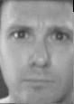 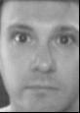 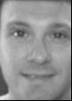 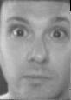

Angry Neutral Happy Surprised

The database we found fits really well with our approach, because those are the exact pictures we want to detect in our minimum goal (we will probably use some of the 400 images as training set and use some ambiguous ones as our test set.). This is the our basic training images that we are going to use to train our system.

# Proposed Algorithm

After reading several research papers, we have a pretty good understanding of what we are trying to accomplish. So we came up with an algorithm that we want to explore.

Since we learn PCA and SVM from the class, we are thinking that we can use PCA to get the eigenface and generate equation for Time-elapsed photography, and use the three coefficients as three-dimensional feature vector and train the system with SVM.

Code implemented so far

We used PCA to generate an eigenface for all the pictures that we have and have a deeper understand of PCA. The code that we implemented so far is also attached in the zip file submitted.

Git  
git clone https://github.com/henrik-rose-hulman/CSSE463.git